**SQL STATEMENTS**

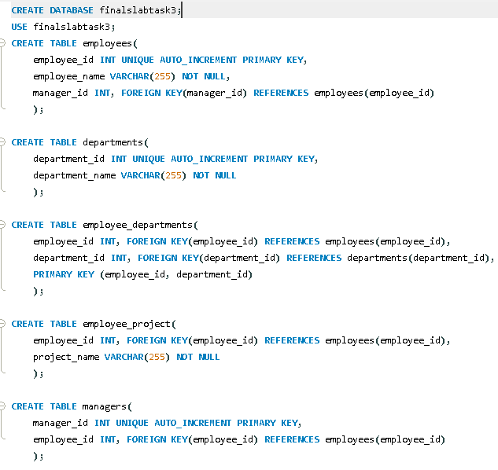

**TABLE STRUCTURE**

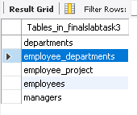

**RELATIONAL SCHEMA**